Zucchini and chorizo slice
This simple zucchini and chorizo slice is packed full of healthy vegetables and eggs and has the added bite of chorizo sausage. Bake some for a light lunch to have with salad or slip some into lunchboxes.

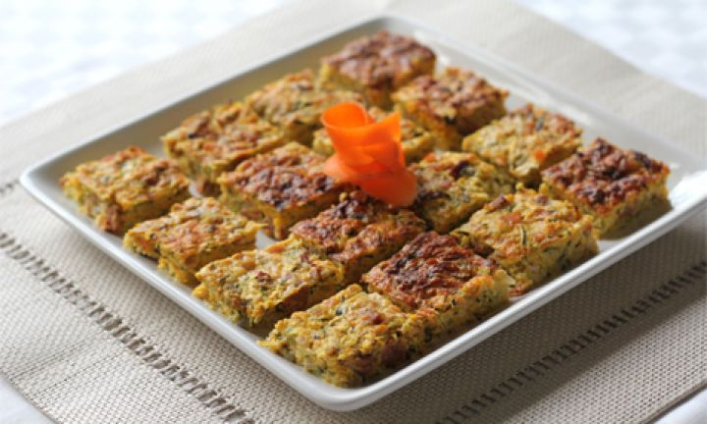

ingredients
- 3 zucchini, grated
- 1 red onion, chopped
- 1 carrot, grated
- 4 slice shortcut bacon, diced
- 2 cooked chorizo sausages, diced
- 1 cup goats cheese
- 1/2 cup gluten free plain flour
- 3 eggs, lightly beaten
- salt and pepper

method
- Preheat oven to 180°C. Line a slice tray with baking paper and set aside.
- Place all ingredients in a bowl and mix until well combined.
- Pour into slice tray and smooth the top with the back of a spoon.
- Bake for 55-60 minutes.

