Vegetable fettucini with fresh tomato sauce

serves: 4 | prep: 0:10 | cook 0:10
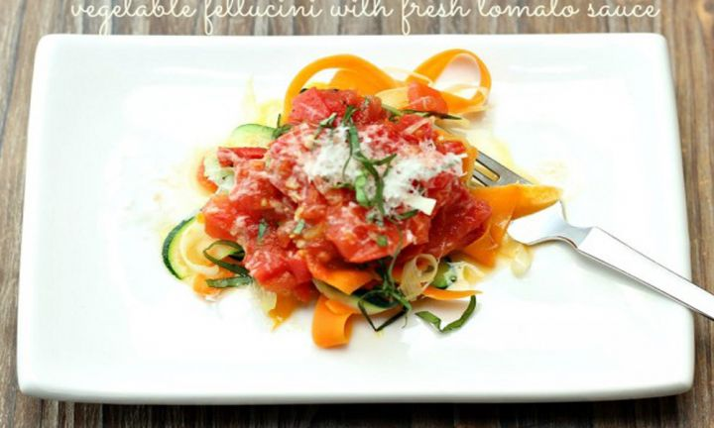

ingredients
- 2 tsp olive oil
- 2 garlic clove (minced)
- 550 g tomato (fresh, chopped)
- 1 tbs red wine vinegar
- 1 tsp sugar
- 10 basil leaves
- 8 tbs goats feta
- Fettucini
- 3 tsp olive oil
- 1 leek (large, cut into ribbons)
- 2 carrot (large, cut into ribbons)
- 3 zucchini (large, cut into ribbons)
- 1 pinch salt

method
- To make the tomato sauce: Place oil in a non-stick frying pan, add garlic and heat on low. Cook for 1-2 minutes until garlic becomes fragrant. Add remaining ingredients (except basil and cheese), turn up the heat and simmer for 5 minutes.
- To make the fettucini: Heat oil in a large non-stick frying pan, add vegetables with a pinch of salt and cook for 2-3 minutes, moving the pan around often. This will give you a lovely crunchy texture but if you prefer soft, cook it for a little longer – you’ll know when it’s done to your liking.
Serve fettucini in bowls topped with sauce, a sprinkling of fresh basil and goats feta.

