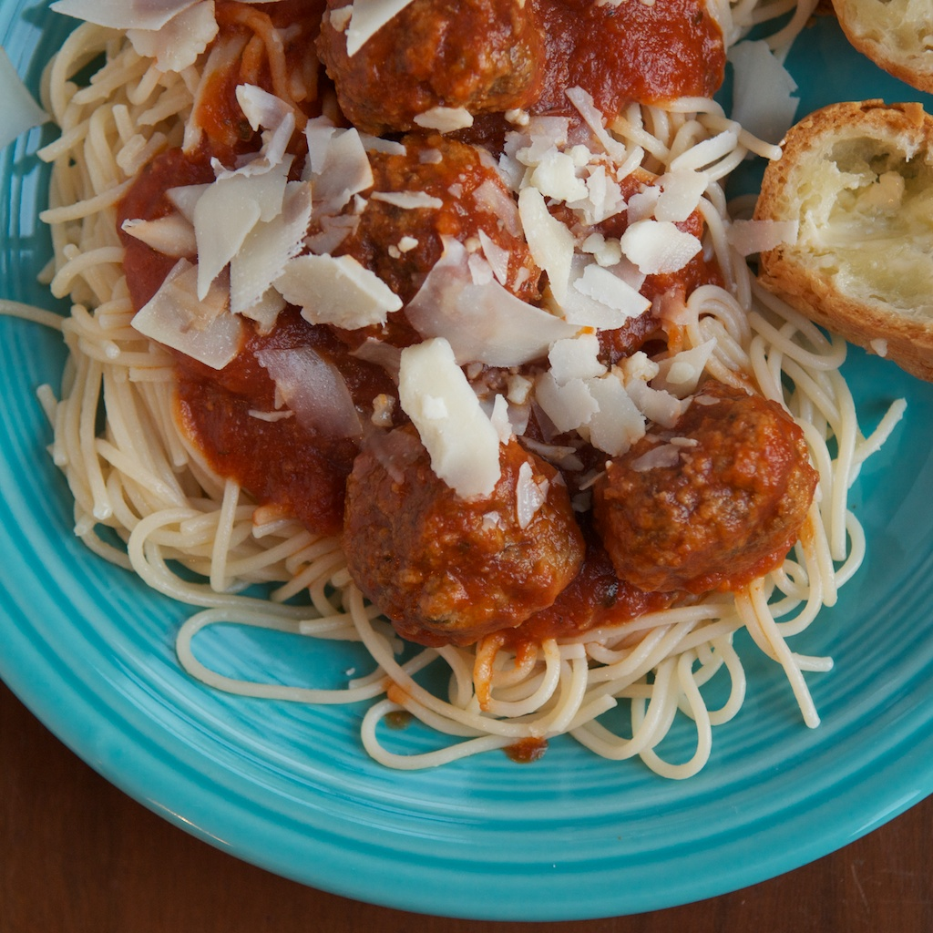

Spaghetti & Meatballs
SERVES: Yields 14 meatballs
TIME: 1 hour 20 minutes
TAGS:
- Corn Free
- Dairy Free (for the meantime use goats feta)
- Soy Free

Ingredients
For the Meatballs
- 500 G BEEF and 500 G pork
- 1 pound ground beef
- 1 cup GF bread crumbs (make your own by taking stale bread and processing in the food processor)
- 1 teaspoon parsley flakes or 2 Tablespoons chopped fresh parsley
- ½ cup goats feta
- 2 teaspoons salt
- ½ teaspoon pepper
- ¼ teaspoon ground nutmeg
- 1 egg beaten
- ½ cup warm water
- Vegetable oil
- Olive oil

For the Sauce
- 1 Tablespoon good olive oil
- 1 yellow onion, chopped
- 1 garlic clove, minced
- ½ cup red wine
- 1 28-ounce can diced tomatoes
- ½ teaspoon parsley flakes
- 1 ½ teaspoon kosher salt
- ½ t teaspoon pepper
Serve over
- 1 ½ 500G GF spaghetti

Preparation
1. Mix the ground meats, bread crumbs, parsley, GOATS FETTA, salt, pepper, nutmeg, egg and ½ cup warm water in a bowl.
2. With your hands, lightly form 2-inch meatballs. Yields 14 – 16 meatballs.
3. Pour equal amounts of vegetable and olive oil in a large skillet to ¼ inch depth. Heat the oil. Brown the meatballs on medium-low heat in batches. Carefully turn them to brown all sides. About 10 minutes for each batch.
4. Remove the meatballs to a plate and discard the oil, but do not clean the pan.

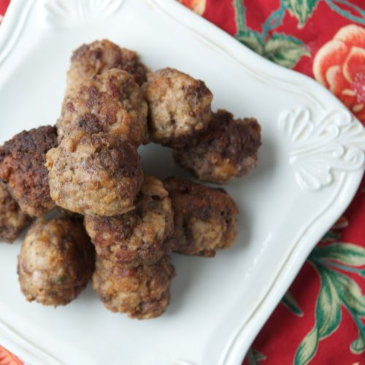

5. For the sauce, heat olive oil in the same pan. Add the onion and sauté over medium heat until translucent, 5 – 10 minutes.
6. Add the garlic and cook for one more minute.
7. Add the wine and cook on high heat, scraping up the brown bits in the pan, until almost all the liquid evaporates – about 3 minutes.
8. Stir in the tomatoes, parsley, salt and pepper.
9. Return the meatballs to the sauce, cover and simmer on low for about 30 minutes, until meatballs are cooked through.
10. Serve over cooked spaghetti AND SPRINKLE WITH GOATS FETTA

