4.9 from 16 reviews

Shepherd’s Pie with Cauliflower Topping (GAPS, Paleo, Grain-Free)

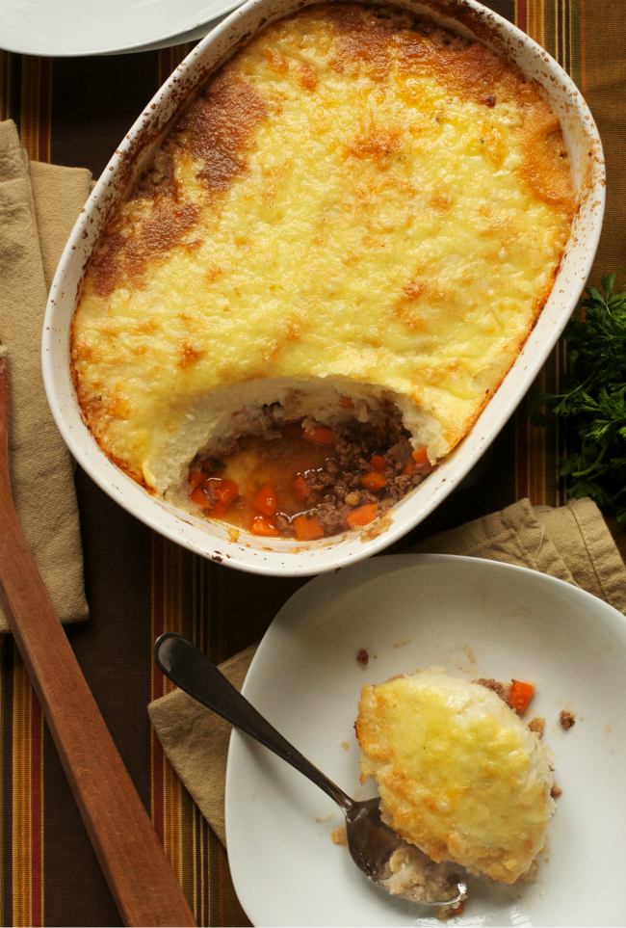

Print

Prep time
30 mins

Cook time
30 mins

Total time
1 hour

Author: Oven Love
Recipe type: Main Dish
Serves: 4-6

Ingredients
- 1 head cauliflower, chopped into florets
- 2 tablespoons fat (lard, tallow, ghee, coconut oil, etc)
- 1 small onion, diced
- 2 celery ribs, diced
- 2 carrots, diced
- 2 cloves garlic, minced
- 1 pound ground beef or lamb
- ¼-1/2 cup homemade beef broth or organic stock
- 1 tablespoon tomato paste
- 2 tablespoons chopped parsley
- salt and pepper to taste
- 2 tablespoons fat (lard, tallow, ghee, etc)
- ½ cup goats fetta

Instructions
- Preheat the oven to 400 degrees. Grease a 2-3 quart casserole dish and set aside.
- In a large pot, steam or boil cauliflower until tender.
- Heat 2 tablespoons of fat in a large skillet or saucepan over medium high heat. Add the onion, celery, carrots and garlic and cook until beginning to soften, around 5 minutes.
- Add the ground meat to the pan and cook until browned. Add beef broth as necessary to keep the mixture wet. Add the ketchup or tomato paste (if using), parsley and season with salt and pepper. Let simmer while you prepare the cauliflower topping.
- To make the topping, drain the cooked cauliflower. Mash or puree with a stick blender until smooth. Add 2 tablespoons of fat and season with salt and pepper.
- To assemble, spread the meat mixture on the bottom of the dish. Top with the cauliflower mixture and smooth with a spoon. Cover with goats fetta, if using.
Bake for 30 minutes or until the top is brown and bubbly. Serve warm.

