Sesame Beef Stir Fry (gluten-free)

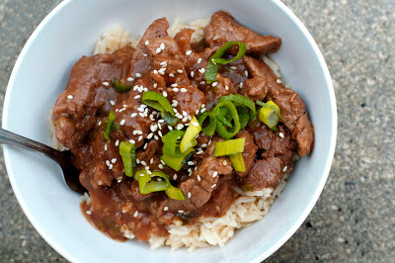

Print

Prep time
10 mins

Cook time
15 mins

Total time
25 mins

adapted from The Newlywed Cookbook by Robin Miller
Author: Oven Love
Recipe type: Main Dish
Serves: 2-4

Ingredients
- 1 tablespoon sesame oil
- 1 tablespoon olive oil
- 1 bunch green onions, chopped (set aside some of the green parts for serving)
- 2 cloves garlic, minced or pressed
- 1 tablespoon grated/minced fresh ginger
- 1- 1½ pounds beef tenderloin or top round steak, sliced into thin strips
- 1 tablespoon sesame seeds, plus more for serving
- 3 tablespoons gluten-free soy sauce or tamari
- ¼ teaspoon black pepper
- 1 tablespoon corn starch
- ½-1 cup organic stock
- cooked rice for serving

Instructions
- In a large skillet or wok, heat the sesame and olive oils over medium heat. Add the green onions, garlic and ginger and cook until fragrant; about 2 minutes. Add the beef and sesame seeds and cook for 5 minutes or until beef is browned, stirring frequently.
- When beef is brown, add the soy sauce and black pepper and stir to deglaze the pan.
- Dissolve the cornstarch in ½ cup beef stock and add to the pan. Simmer until the sauce thickens, adding more broth if necessary.
Spoon over cooked rice, top with additional green onions and sesame seeds and enjoy.

