Rice paper rolls
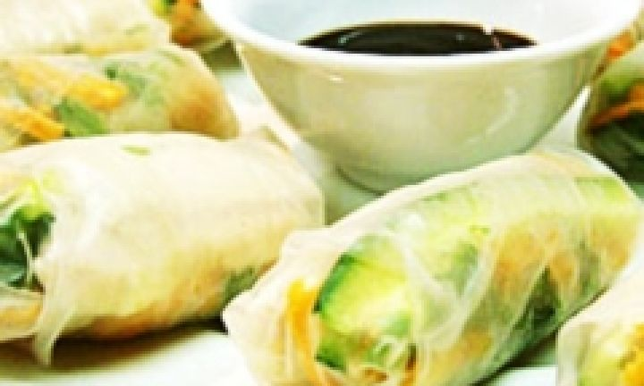

ingredients
- 10 sheets rice paper (gluten-free)
- 1 cup (about 200g) cooked chicken, shredded
- 1 carrot, peeled and grated
- 1 cucumber, halved, seeds removed, cut into 5cm strips 1 cup shredded lettuce
- 2 tablespoons fresh mint leaves, chopped
- 2 tablespoons fresh coriander leaves, chopped
- ½ cup gluten free Hoisin sauce

method
- Fill a large bowl with warm water.
- Dip a sheet of rice paper into the water for about 10 seconds, just until it starts to soften (if you leave it in too long it becomes very tricky to handle), then transfer the sheet to a dinner plate.
- Place a few pieces of chicken, carrot, cucumber, lettuce and herbs in a pile on one end of the rice paper.
- Fold the top of the rice paper over the ingredients, then fold in each side and roll up.
- Repeat with remaining ingredients.
Serve on a large plate with Hoisin dipping sauce.

