Peanut butter protein balls
These no bake protein balls are a perfect after school snack for your kids. Being high in protein means they will give the children that afternoon boost to keep them going until dinner time. You can even get the kids to make them.

serves: 15 | prep: 0:20
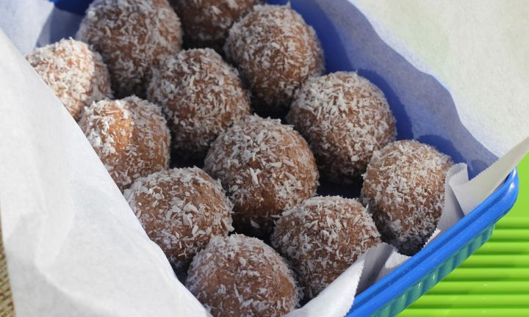

ingredients
- 1 cup vanilla protein powder
- 1 cup peanut butter
- 1/2 cup honey
- 1 cup desiccated or flaked coconut

method
Mix all ingredients except coconut in a bowl and roll into walnut sized balls.Roll balls in coconut to coat and refrigerate until firm.

