No bake coconut and date balls

prep: 0:10
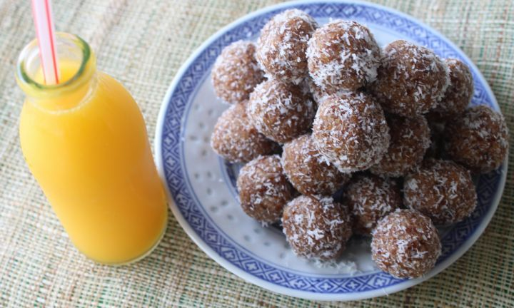

ingredients
- 3 cups desiccated coconut
- 2 cups (200g) pitted dates

method
1
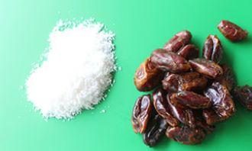
- 1. Place 2 cups of coconut and the dates into a blender or food processor.
2
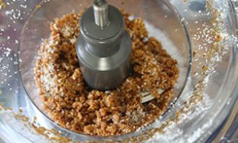
- 2. Process on high speed for 3-4 minutes, pausing to scrape down sides as needed.
3
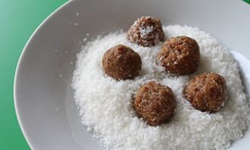
- 3. Remove from processor and roll teaspoon-sized balls. Roll in remaining 1 cup of coconut.
4
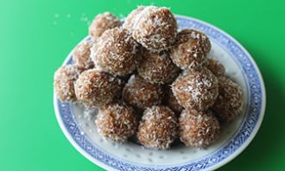
4. Pack in portions for snacks, to put in lunch boxes and keep on hand to satisfy a sweet tooth in a healthy way.

