Mini Mexican Zucchini Boats

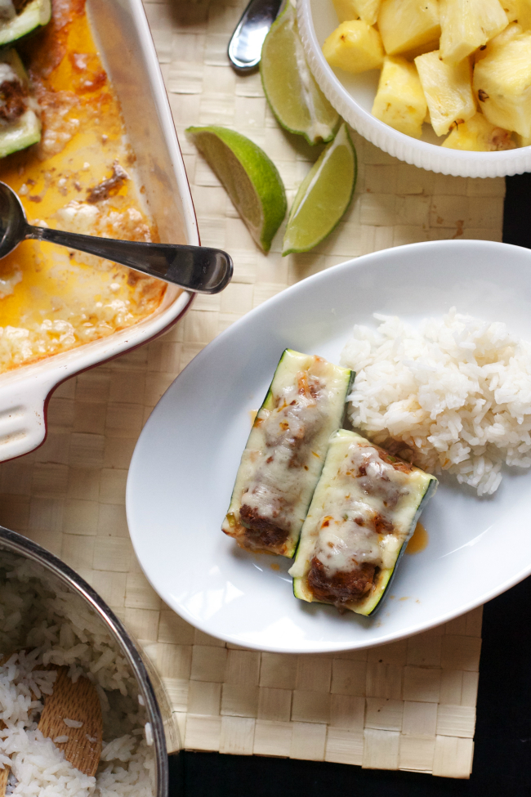

Print

Prep time
20 mins

Cook time
30 mins

Total time
50 mins

*To make things even quicker, you can substitute about 3-4T taco seasoning for the spices.
Author: Oven Love
Recipe type: Main Course
Serves: 4-6

Ingredients
- 4 medium zucchinis, ends trimmed
- 1 pound ground beef (I prefer grass-fed)
- ½ onion, minced
- ½ green bell pepper, minced
- 1-2 garlic cloves, minced/pressed/grated
- 1 tablespoon tomato paste (optional, not Paleo-approved)
- 1 jalapeno pepper, seeded and minced (optional)
- 1 tablespoon chili powder
- 1 tablespoon cumin
- 1 tablespoon smoked paprika
- 1 teaspoon oregano
- 2 teaspoons salt
- cracked pepper to taste (probably around 1 teaspoon)
- 1 cup goats fetta

Instructions
- Preheat the oven to 375. Grease the bottom of a large baking dish.
- To prepare the zucchinis, cut them in half lengthwise and scoop out the flesh to make a channel. Set aside.
- To prepare the filling, mix the ground beef, onion, bell pepper, garlic, jalapeno, tomato paste (if using) and spices in a medium bowl.
- To assemble, fill the zucchinis with the ground beef mixture. Then cut each zucchini in half (or smaller sections if you life). Place the mini zucchini boats in the greased dish.
- Bake for 20 minutes. Pull out of the oven, top with the shredded cheese and bake for another 5-10 minutes or until the zucchini is soft and the cheese is melted. If you’re not using cheese, bake about 30 minutes until the zucchini is soft and the filling is set.
Serve warm and enjoy.

