Mini frittatas

serves: 12 | prep: 0:15 | cook 0:30
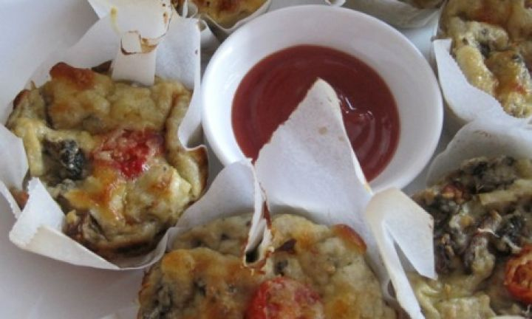

ingredients
- 4 free range eggs
- 3/4 cup goats feta
- 3/4 cup (180ml) coconut milk
- 1/2 cup (40g) goats milk cheese,grated. Plus an extra 1/3 cup (35g) to sprinkle over frittatas before baking.
- 1 x medium leek or 1 x medium onion, finely diced
- 8 mushrooms, diced
- 1 cup (90g) gluten free breadcrumbs
- 1 tsp Dijon mustard
- 6 cherry tomatoes, halved

method
- Pre-heat oven to 200C (180C fan-forced). Grease a 12-hole muffin tray and line each hole with a square of baking paper. Set aside.
- Place all the ingredients, except the cherry tomatoes, into a large bowl and mix well to combine.
- Use a 1/4 cup measure to scoop the mixture into the muffin tray. Top each frittata with half a cherry tomato and a sprinkling of tasty cheese.
Bake for 25-30 minutes or golden brown and crispy-looking on top.

