Mediterranean lamb casserole

prep: 0:20 | cook 2:00
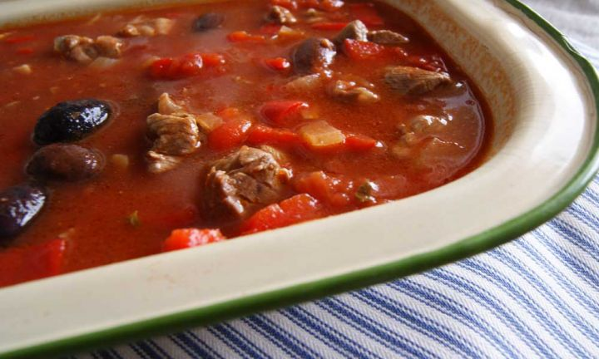

ingredients
- 1 tbsp (20ml) olive oil
- 1 brown onion, peeled and sliced
- 500g shoulder of lamb, diced into 4cm pieces
- 2 stalks rosemary
- 2 cloves garlic, peeled and very finely chopped
- 2 stalks lemon thyme
- 1 red capsicum, diced
- 1/4 cup pitted black olives
- 1 tin (400g) diced tomatoes
- 1 cup (250ml) water

method
- Preheat the oven to 140°C conventional (120°C fan-forced).
- Heat oil in a large pan (with a lid) over a medium-low heat and cook the onion for 5 minutes, or until soft and translucent.
- Add the lamb, rosemary, garlic, lemon thyme, capsicum, olives, tomatoes and water and stir well to combine.
Cover with the lid and place in the oven for about 2 hours.

