Homemade bliss balls
These easy, no-bake homemade bliss balls are perfect for lunch boxes or an after school snack. We're talking super healthy and super delicious.

prep: 0:10 | cook 0:10
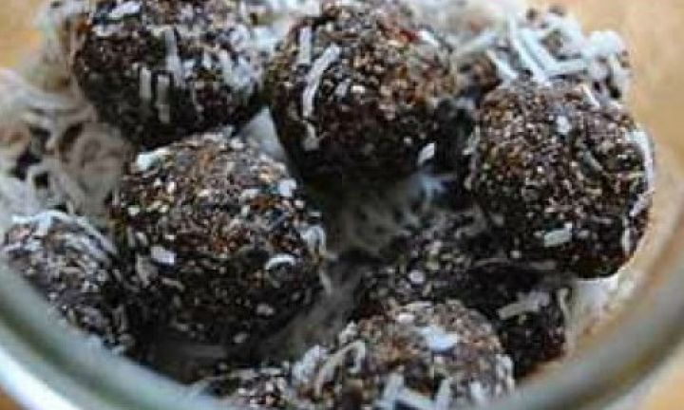

ingredients
- 1 1/2 cups pitted dates
- 1/4 cup sunflower seeds
- 2 tbsp coconut oil
- 3 tbsp chia seeds
- 2 tbsp dark cocoa powder
- 1 tsp vanilla extract
- 1/2 cup (45g) desiccated coconut, for rolling

Method:

Mix them together!!!

