Gluten-free pasta salad

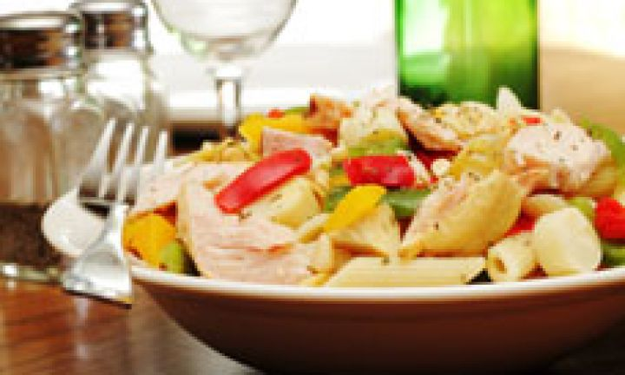

ingredients
- 1 serving gluten-free pasta
- 1 cup cherry tomatoes, halved
- ½ cucumber, cubed
- ½ green capsicum, sliced
- ½ red capsicum, sliced
- ½ yellow capsicum, sliced
- handful green beans, topped, tailed and cut in half
- ½ chicken breast, cooked and shredded (optional)
- ½ avocado, diced
- 2 tbsp balsamic vinegar
- 2 tbsp olive oil

method
- Cook the gluten-free pasta and drain and place in a medium bowl.
- Add all the ingredients and toss.
- Combine the ingredients for the dressing in an airtight jar and shake vigorously.
Pour over salad and serve.

