Chicken and mango salad
This chicken and mango salad recipe is a great summer standby and is given its fresh zing with the lime mayonaise dressing. Take it on a picnic or share it with friends at home.

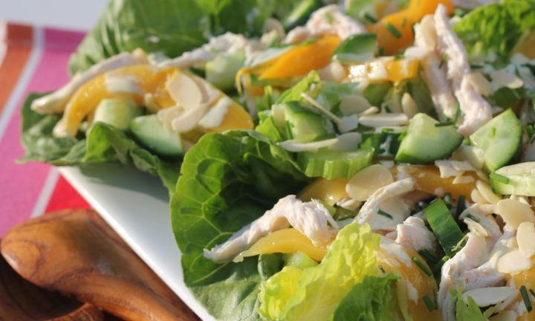

ingredients
- 4 chicken breasts, panfried and sliced
- 1 bag of baby spinach leaves (150g)
- 2 fresh mangoes, peeled and sliced or 1 tin mangoes, drained and sliced
- 1 capsicum, de-ribbed and sliced
- 1 red onion, peeled and sliced
- 1 punnet cherry tomatoes, halved
- 1 cup whole egg mayonnaise
- 1/4 cup lime juice

method
- In a bowl, combine the mayonaise and lime juice. Set aside.
- Toss together the spinach, capsicum, onion and cherry tomatoes. Arrange on a platter.
- Lay the chicken on top of the salad and the mango over the chicken.
Drizzle with lime mayonnaise.

