Caramelised onion and sweet potato frittata
The sweetness of the onions and potatoes are a lovely foil for the sharp parmesan cheese in this frittata. If you're organised enough to cook your vegetables ahead of time, dinner can be ready in less than 15 minutes.

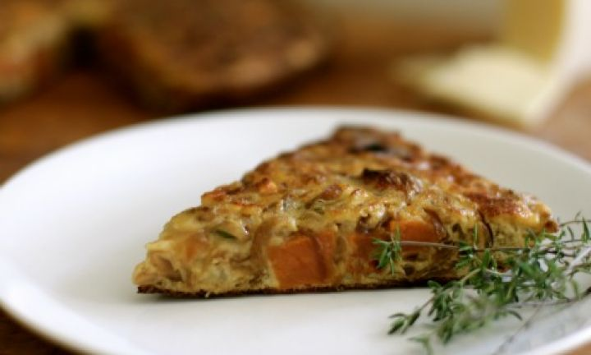

ingredients
- 60ml (3 tbsp) olive oil
- 2 brown onions, sliced
- 1 tsp brown sugar
- 5ml (1 tsp) balsamic vinegar
- 250g sweet potato, peeled
- 6 eggs
- 2 tbsp goats cheese
- 1 tsp thyme leaves

method
- Preheat oven to 190°C conventional (170°C fan-forced).
- Heat 20ml (1 tbsp) olive oil in a small saucepan with a lid. Add onions and stir to coat, then seal with lid and cook over very low heat for 20 minutes, stirring occasionally. Add sugar and vinegar and cook for a further 2 minutes.
- Meanwhile, chop sweet potato into 1cm dice. Toss in 20ml (1 tbsp) olive oil, season well with salt and pepper, and bake for 25-30 minutes until soft.
- In a large bowl, using a fork, beat eggs. Stir through caramelised onions, baked potato cubes, parmesan and thyme leaves. Season well. Heat remaining oil in a 25cm frypan over very gentle heat. Pour in egg mixture and scrape base of pan with a spatula intermittently until eggs begin to set. Leave for 8-10 minutes until almost done. Place under a grill for a further 2 minutes until the top has just set.
Serve wedges of frittata with a salad of rocket and balsamic.

