Breakfast burritos

prep: 0:10 | cook 0:10
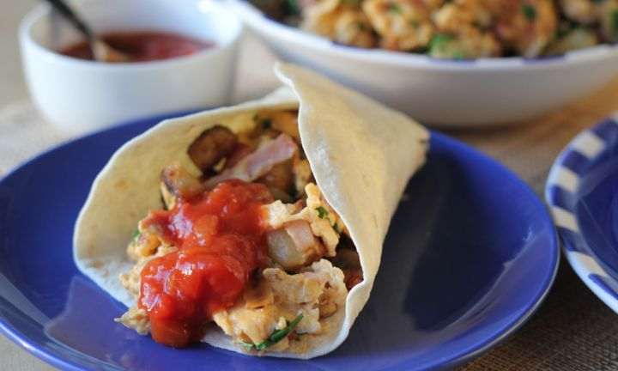

ingredients
- 3 tbsp olive oil
- 500g potatoes, cubed
- 1 onion, diced
- 3 rashers middle bacon, chopped
- 6 eggs
- ¼ cup parsley, chopped
- 1 cup salsa
- 8-10 mountain bread, spelt bread preferably

method
- In a large frying pan, heat the oil and cook the potatoes for about 10 minutes until golden and cooked through.
- Add onion and bacon. Cook until the onion is translucent.
- Crack the eggs over the pan and scramble until the eggs are cooked.
Toss in parsley. Serve egg and potato mixture with salsa sauce, wrapped in warmed tortillas.

