BBQ beef san choi bao

prep: 0:10 | cook 0:10

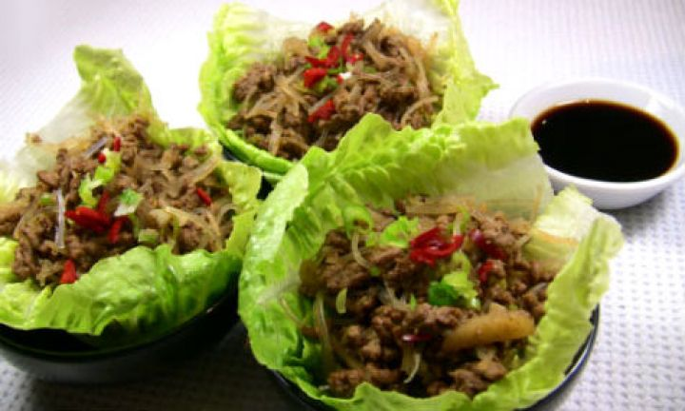

ingredients
- 500g lean beef mince
- 1 tsp vegetable oil
- 1 garlic clove, minced
- 2 tsp freshly grated ginger
- 1 chilli, finely chopped (optional)
- 1 can water chestnuts, finely sliced
- 1 tbsp hoi sin sauce
- 2 tbsp soy sauce
- 4 spring onions, finely chopped
- 2 cups cooked rice vermicelli (about 65g uncooked)
- 1 iceberg lettuce or 2 butter/green oak lettuce, washed and separated out into lettuce cups

method
- Heat oil in large wok or frying pan and add beef.
- Brown beef and add garlic and ginger.
- Cook a further minute before adding chilli, water chestnuts, hoisin sauce and soy sauce.
- Cook for a minute or so before adding spring onion and rice vermicelli.
Stir through and serve in lettuce cups.

