Bacon and egg cups
Bacon and egg cups are a great dish to serve when you are having guests for brunch or having a lazy Sunday at home. They are also very portable for food on the go.

prep: 0:15 | cook 0:20
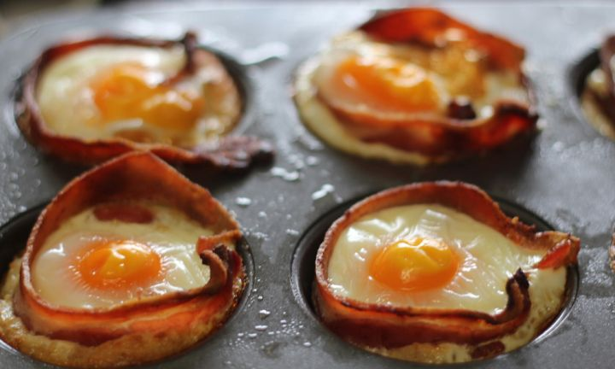

ingredients
- 12 slices gluten free bread
- 12 rashers middle bacon, rind removed
- 12 eggs
- cooking spray

method
- Using a scone cutter, cut out 12 rounds of bread. Spray a muffin tin with cooking spray and place the bread rounds in the bottom of each cup.
- Preheat oven to 180°C/160°C fan-forced.
- Remove the eye (big round piece) from each rasher of bacon and place back in the fridge to use for another recipe. Spray a frying pan with cooking spray and lightly fry the bacon rashers on each side until just cooked.
- Place one rasher inside each muffin cup, lining the edge of the cup and just inside the bread.
- Crack one egg into each cup so it is sitting on top of the bread and inside the bacon.
- Place the tray in the oven and bake for 15-20 minutes or until the eggs are set.
Remove from oven and serve immediately.

